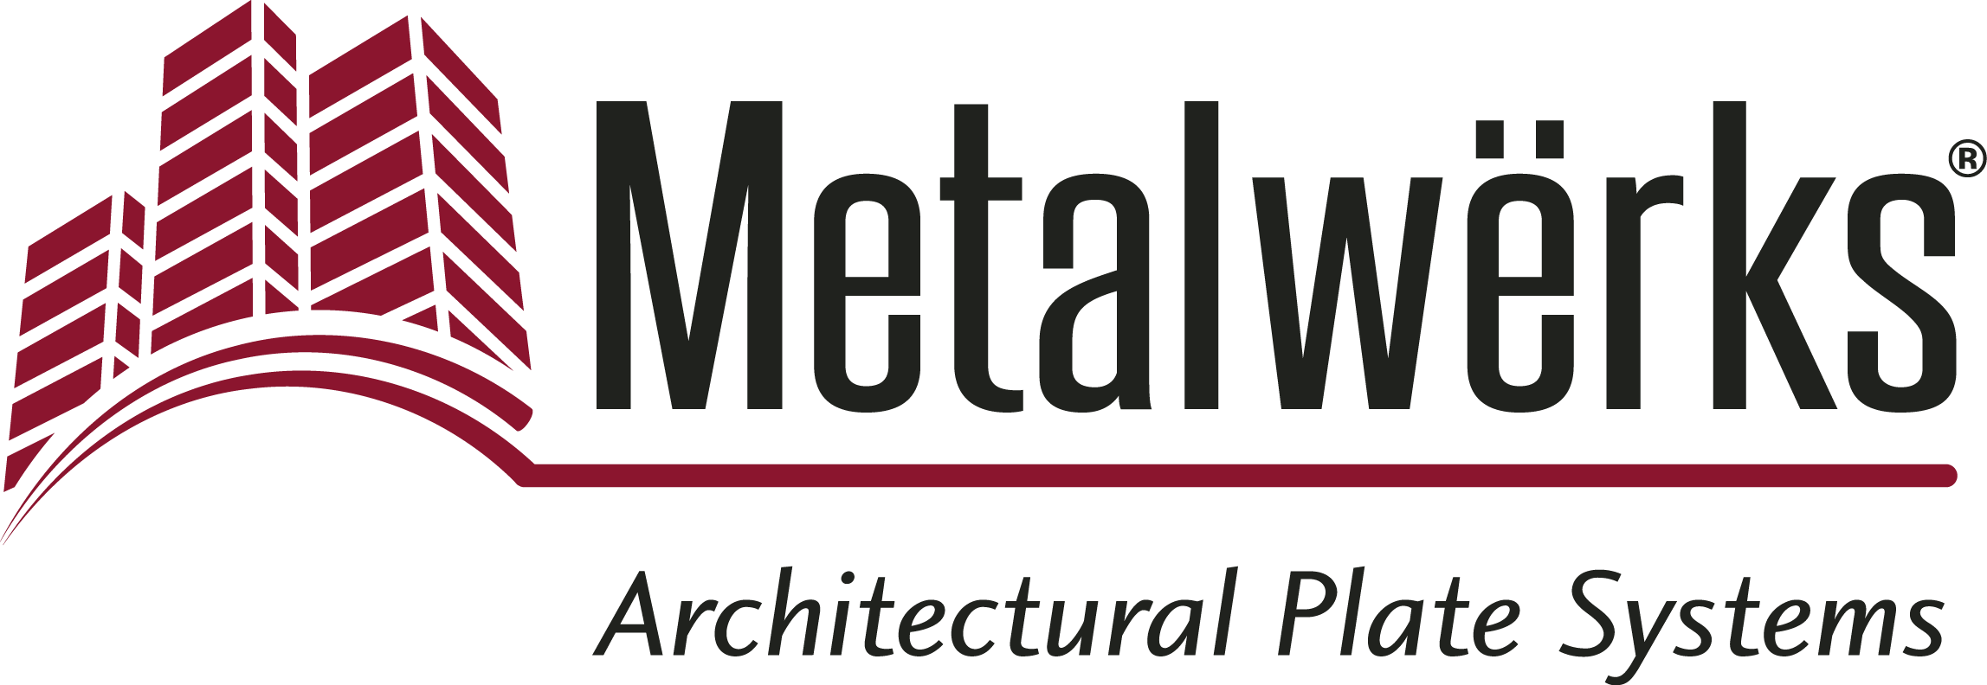

FOR IMMEDIATE RELEASE
Contact: Nick Murosky, LarsonO’Brien
Phone: 412-831-1959 x123 E-mail: nick@larsonobrien.com
Date: November 16, 2017
Photos: http://www.lopressroom.com/metalwerks/morgan-state

Metalwërks® Products Complete Morgan State University’s New
Business School and Pedestrian Bridge
Arcwall™, Econowall™, and Additional Exterior Features Meet Design and
Budget Requirements

KENNETT SQUARE, PA… Metalwërks®, a leader in precision metal plate exterior façade systems, provided 82,000 total square feet of its products for a new construction project at Morgan State University’s new business school, and the pedestrian bridge that connects the east and west sides of the campus.

The new six-story Earl G. Graves School of Business and Management is the jewel of the long-awaited Morgan Business Center. The building is clad with a number of Metalwërks products, including Arcwall™ DBV Spline panels, custom perforated column covers and skylight panels, and custom Econowall™ canopy and plate accent features throughout.

Before Metalwërks’ involvement, the original exterior specification was for terra cotta tile, which was coming in over budget. With no additional funding available, Metalwërks collaborated with design architects at Kohn Pedersen Fox Associates (KPF) and Ayers Saint Gross — the local architect of record — to study a variety of wall systems, ultimately providing one that would save on funding considerably and win them the project in August of 2013.

The triangular-shaped structure takes advantage of the site’s significant north to south grade change – evident at a landscape view of the building. Its subtle curvature and wedge shape, along with various curtainwall levels, provided a challenge during the design phase – overcome by Metalwërks’ breadth of accommodating products and an integrated project team approach.

“Even with such a complex design, Metalwërks fabricated the facade flawlessly,” says Tarek Saleh, Senior Associate at Ayers Saint Gross, the architect of record. “Their design-build process was a great success, and the final product looks incredible.”

On the exterior of the business school building, varying sizes of Arcwall DBV (Drained, Back Vented) Spline panels were specified between vertical window units. The assorted panel sizes were incorporated and installed seamlessly.

Metalwërks’ custom canopy and the additional plate accent features utilize 0.125 aluminum with a Metallic finish to accentuate the building’s horizontal lines and accent features, while the main façade featured vertically-oriented custom-ribbed Econowall and Arcwall to match the aesthetic of the original terra cotta tile façade and earth tones that lines the second and third levels of the building. The Econowall rainscreen wall system features narrow micro ribs of 3/4” x 1” deep in .040 aluminum – the exact tolerances required to assure proper dimensional consistency and alignment of ribs from panel to panel.

The ground floor terrace opens up to the commons area accented by a colonnade of metal “fin” sunshades, which shield the interior spaces from the late afternoon sun. This third, custom component originally called for a random perforation pattern in zinc with custom faux finishes. In coordination with the architects, Metalwërks developed the preferred appearance and spacing in 1/8” aluminum plate, which was finally selected for its superior flatness and workability and lower cost over the custom zinc finish.

Within the building, the interior atrium features another custom-radiused panel system with a pre-selected triangular hole pattern for the skylights – allowing natural light to flood into the main atrium space; a space that leads to the newest innovations of Morgan State University – computer labs, classrooms, a real-time Capital Markets stock trading center, seminar rooms, a 299-person-capacity auditorium, and a Center for Innovation.

The pedestrian bridge that links the two sides of the Morgan State campus is equipped with Arcwall plate rainscreen wall cladding, covering the bridge, ramps, and elevator. The design incorporates approximately 1,000 rectilinear and pattern cut/wedge shaped flat panels in multiple colors to match Morgan State’s affiliated blue and orange school colors.

The end result is a bridge with a lot of color and flair, utilizing arching accents and colorized glass rail panels. The bridge serves as banner for the university, boldly displaying the college’s name in white lettering to passersby.

"We had a ton of unique panels, and everything was custom-made and immense,” adds Saleh. “Metalwërks responded with incredible shop drawings that resulted in a beautiful, clean facade.”

The project is the start of a “new campus” on the western side of Hillen Road – so the new pedestrian bridge is a vital link for students and staff to navigate from one side to the other.

The Morgan Business Center is just one of the planned projects for the “new campus.” Metalwërks was pleased to have such a significant role in the aesthetic outcome and exterior performance of the new building and bridge, and to be able to provide Morgan State University with industry-leading materials and sustainable design.

Arcwall was the primary Metalwërks product used throughout the project – chosen for its high design flexibility and exceptional performance. Arcwall provides high resistance to denting or puncturing, and is manufactured with fully mitered and welded corners, ground smooth for an excellent, seamless appearance.

Econowall is an economical drained and back-ventilated rainscreen cladding system with dry-set panels, interlocking longitudinal joints, and rigid finished end conditions.

The Earl G. Graves School of Business and Management is fully accredited by The Association to Advance Collegiate Schools of Business (AACSB) International. They are one of the less than five percent of business programs worldwide to have received the coveted AACSB accreditation.

Morgan State University officials consider the new business school to be an attractive university focal point; one that will attract top students from around the country in addition to the most talented faculty.

The Earl G. Graves School of Business and Management was completed in October 2015 and the bridge was completed in May 2016. The project team consisted of design architect KPF, New York, NY, architect of record Ayers Saint Gross, Baltimore, MD, and general contractor Gilbane Building Company, Providence, RI.

About Metalwërks:
Founded in 1968, Metalwërks is the leading U.S. manufacturer of precision high-performance metal plate exterior facade systems, integrated curtain wall components, and custom architectural features. Metalwërks works with national and regional glass, ornamental metal, and panel companies, as well as architect and design firms, to provide high quality architectural metal wall systems and features. The company works in close collaboration with top architects to achieve new levels of form and function in systems precision-manufactured from solid metal plate. Metalwërks is unparalleled in the quality, diversity, integrity and reputation of its systems, services, and employees. For more information, visit: www.metalwerksusa.com.

# # #

