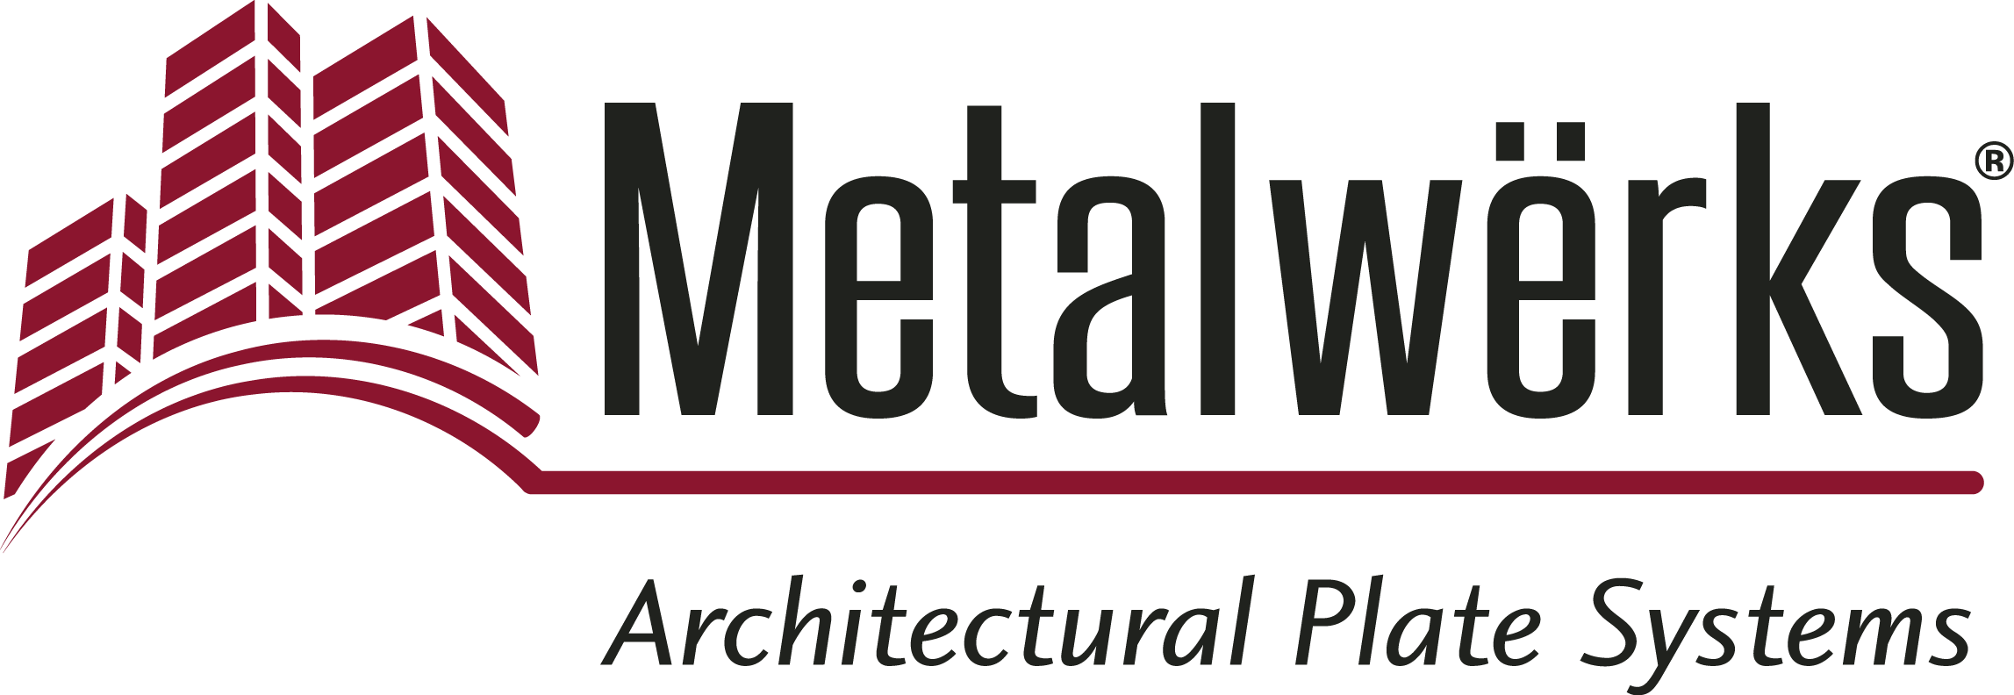

FOR IMMEDIATE RELEASE
Contact: Nick Murosky, LarsonO’Brien
Phone: 412-831-1959 x123 E-mail: nick@larsonobrien.com
Date: February 21, 2017
Photos: http://www.lopressroom.com/metalwerks/Sculpted-3D

Metalwërks® Introduces Sculpted™ 3D* Rainscreen System
Innovation Enables Bold Forms with Interchangeable Design Schemes

KENNETT SQUARE, PA…Metalwërks introduces the Sculpted™ 3D Rainscreen System, a dry-set, solid metal wall panel with three complementary and interchangeable design schemes that produce the boldest three-dimensional forms possible.

Metalwërks Sculpted 3D is now engineered for optional integrated features, including vegetative planters and irrigation for living walls (both patent-pending), and LED lighting for a stunning wall washing effect or backlight effect.

The three Sculpted 3D design schemes – Parametric, Ribbon and Minimal – can be viewed in detail on the new Metalwërks website:
www.metalwerksusa.com/product/sculpted-3d/.

These three design schemes have been pre-formatted for simplicity of use, but are not limited to these schemes alone. Their intent is to provide more interesting options for façade design than what is currently available. Each design scheme lends unique and intriguing forms, rhythms and textures to a wall expanse – and some panels can be installed horizontally or vertically.

- Parametric provides a design that permits the pre-engineered use of custom non-rectilinear profiles with obtuse and sloping lines. This product also provides an area of “blank canvas” for adding randomly or rhythmically-located CNC pattern cut holes, backlighting, or logos/ graphics.

- Ribbon offers an undulating basket weave effect, which can merge with flat wall areas in a seamless fashion.

- Minimal permits an interchangeable set of projecting light cove and planter profiles to an otherwise flat wall cladding system.

Metalwërks Sculpted 3D is a design-forward drained and back ventilated (“DBV”) rainscreen wall system that can be used throughout the entire building façade. In addition to serving as an exterior envelope system, it offers other more ornamental design opportunities such as feature walls; demising/privacy walls; interior lobby spaces; and exterior or interior facades for large public structures such as stadiums, convention centers, hotels, and public transit centers, including airports.

The launch of Metalwërks Sculpted 3D Rainscreen System follows the company’s recent announcement that it will focus all of its efforts on designing and manufacturing its solid metal products.

“The Sculpted 3D Rainscreen System speaks volumes about our company’s commitment to bringing something new and innovative to the design community – a variety of visual forms integrated with multiple functions,” says Stephen Scharr, Director of Business Development, Metalwërks.

About Metalwërks:
Founded in 1968, Metalwërks is the leading U.S. manufacturer of precision high-performance metal plate exterior facade systems, integrated curtain wall components, and custom architectural features. The company works in close collaboration with top architects to achieve new levels of form and function in systems precision-manufactured from solid metal plate. Metalwërks is unparalleled in the quality, diversity, integrity and reputation of its systems, services, and employees. For more information, visit: www.metalwerksusa.com.

*Patent Pending

# # #

