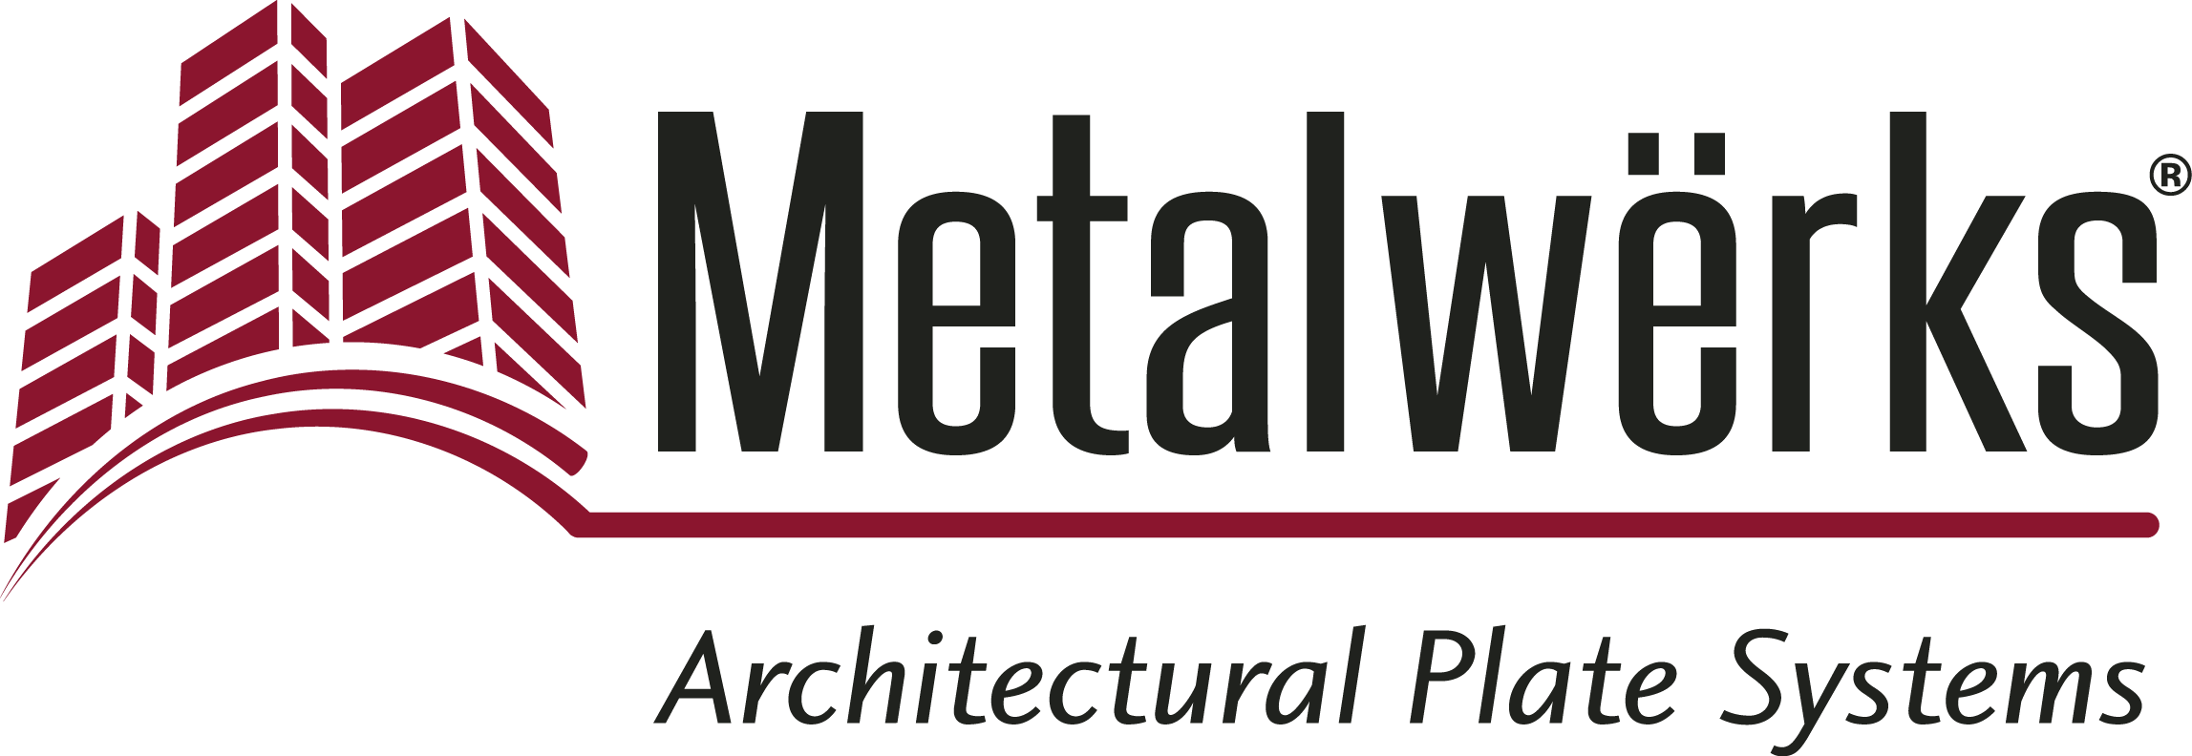

FOR IMMEDIATE RELEASE
Contact: Nick Murosky, LarsonO’Brien
Phone: 412-831-1959 x123 E-mail: nick@larsonobrien.com
Date: June 5, 2017
Photos: http://www.lopressroom.com/metalwerks/hartford-hospital

Award-Winning Hartford Hospital Bone and Joint Institute
Features Metalwërks® Ameriplate™
Solid Aluminum Plate Wall System Creates Graceful, Seamless Look for
Multiple Buildings and Compositions

KENNETT SQUARE, PA… Metalwërks® Ameriplate™ served as the basis of design for the new Hartford Hospital Bone & Joint Institute — a landmark facility in Hartford, CT.

The Bone & Joint Institute is the centerpiece of a campus expansion at Hartford Hospital, including two new buildings connected by a curving bridge. Metalwërks’ Ameriplate wall system clads both buildings and the bridge, creating graceful flowing lines and allowing for design consistency — despite the fact that the two buildings have different styles of rain screen wall construction.

The unique characteristics of the Ameriplate system, along with Metalwërks’ project design assistance, allowed the wall panel façade to appear seamless and flow from one building to the next.

The Metalwërks sales team worked closely with Perkins + Will’s New York City office early in the schematic design and design development phases of the project to create custom details for the façade. This design assist process was particularly effective for coordinating the building envelope details.

“At the beginning of the project, we had a working session with Metalwërks, which helped us understand design challenges, edge details, framing, and other components of the project,” says Robert Goodwin, Principal and Design Director for Perkins + Will. “That session helped to establish a smooth, precise fabrication and installation process.”

Together, Metalwërks, Lymo Construction, Gilbane, and Perkins + Will demonstrated an extremely high level of technical mastery over the challenging design relationships between the walls and the structure.

“This group of professionals understood the need for precision in the layout of this curving and undulating façade. We communicated well and elevated each other’s performance in the pursuit of our common goals,” says Paul Scharr, President and COO of Metalwërks. “The result is an enduring monument to our collective effort, which we are glad to associate with our organizations. I would not hesitate to work with this team of professionals in the future.”

Metalwërks produced 50,000 sq. ft. of curved, flat, and wedge-shaped wall panels in a 2-coat Bone White PVDF coating for the Bone & Joint Institute, and an additional 15,000 sq. ft. of panels for the adjacent Ambulatory Services Building.

“From the initial design to the final installation, the client is extremely happy with the Metalwërks system,” says Don Chambers, Vice President and Senior Project Manager for Lymo Construction. “Every single panel on the facade fit perfectly, even with a complex, curved design."

The end result is an intricate, undulating design across two building facades, with a floating panel effect that can only be achieved with the Ameriplate system. And this design is also a 2017 American Architecture Prize winner, taking home the Bronze for Architectural Design in the Healthcare category.

“The buildings’ curvilinear design required precision in the exterior panels. Metalwërks solid aluminum plate adapts well to curves and remains smooth over the entire exterior surface, achieving the ideal expression of our design,” adds Goodwin.

Ameriplate is a rain screen wall cladding system engineered to provide a “suspended in the air,” crisp, flat-plate appearance. The product is supplied from .125” to .250” thick solid aluminum plate. It is also available in mechanically polished or etched stainless steel in a variety of finishes. Its panel frame is engineered for a variety of orientations, including vertical, horizontal, curved, or trapezoidal-shaped panel surfaces — and even with perforated faceplates.

The Hartford Bone & Joint Institute project was completed in late 2016. The project team included architects Perkins + Will, New York, NY and HDR, Inc., Omaha, NE; general contractor Gilbane Building Company, Providence, RI; and installer Lymo Construction Co., Inc., Merrimack, NH.

For more information about Ameriplate, visit: www.metalwerksusa.com/product/ameriplate

For more information about the American Architecture Prize, visit: www.architectureprize.com

About Metalwërks:
Founded in 1968, Metalwërks is the leading U.S. manufacturer of precision high-performance metal plate exterior facade systems, integrated curtain wall components, and custom architectural features. Metalwërks works with national and regional glass, ornamental metal, and panel companies, as well as architect and design firms, to provide high quality architectural metal wall systems and features. The company works in close collaboration with top architects to achieve new levels of form and function in systems precision-manufactured from solid metal plate. Metalwërks is unparalleled in the quality, diversity, integrity and reputation of its systems, services, and employees. For more information, visit: www.metalwerksusa.com.

# # #

